**AIM**

Write a C program to search a number using Binary Search method

**ALGORITHM:**

• Start the program.

• Read the size of the array n.

• Input the n elements into the array (must be sorted).

• Read the key element to be searched.

• Initialize low = 0, high = n-1.

• Repeat while low <= high:

* Find middle: mid = (low + high) / 2.
* If arr[mid] == key, element is found at mid.
* If arr[mid] < key, set low = mid + 1.
* Else set high = mid - 1.

• If element not found, display "Not found".

• End the program.

**CODE:**

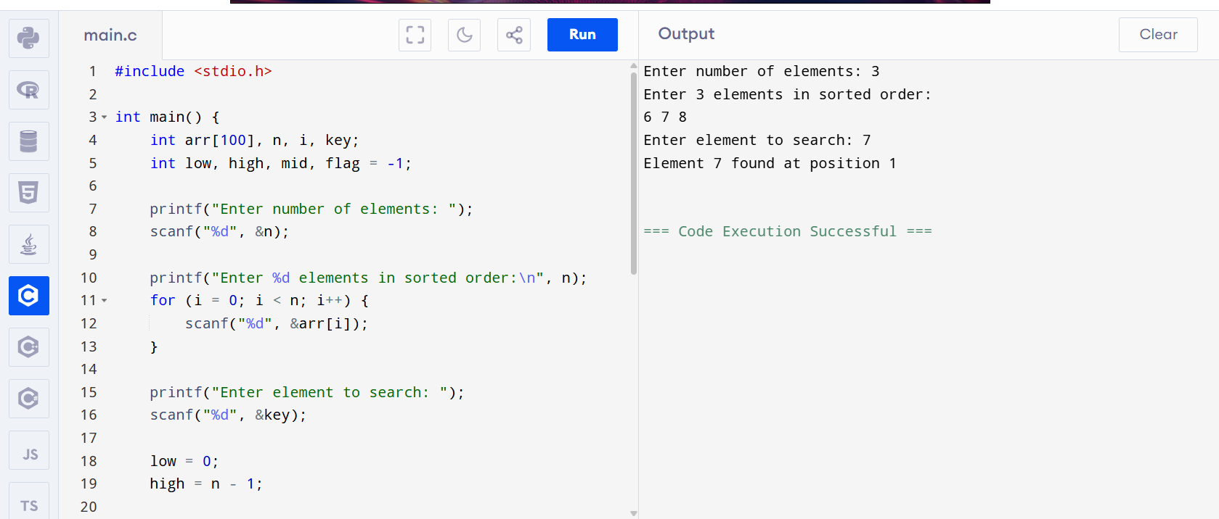

**Output**

Enter number of elements: 3

Enter 3 elements in sorted order:

6 7 8

Enter element to search: 7

Element 7 found at position 1